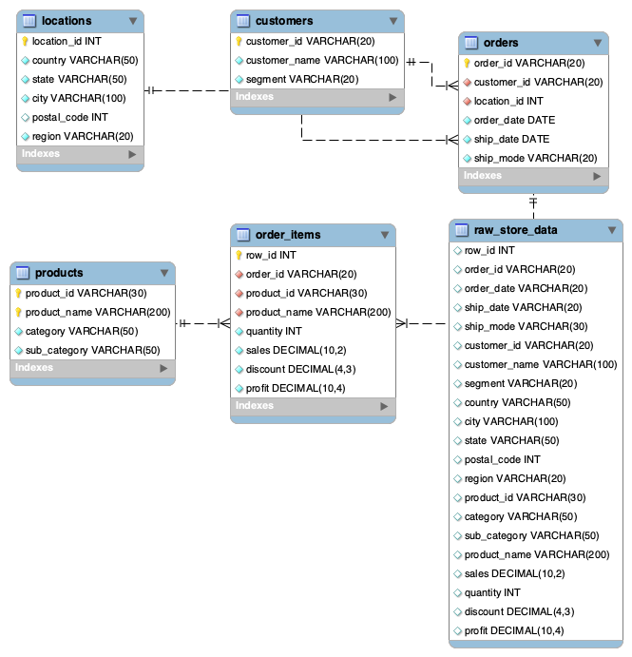

1. Visualization: Sales and profit analysis by product category
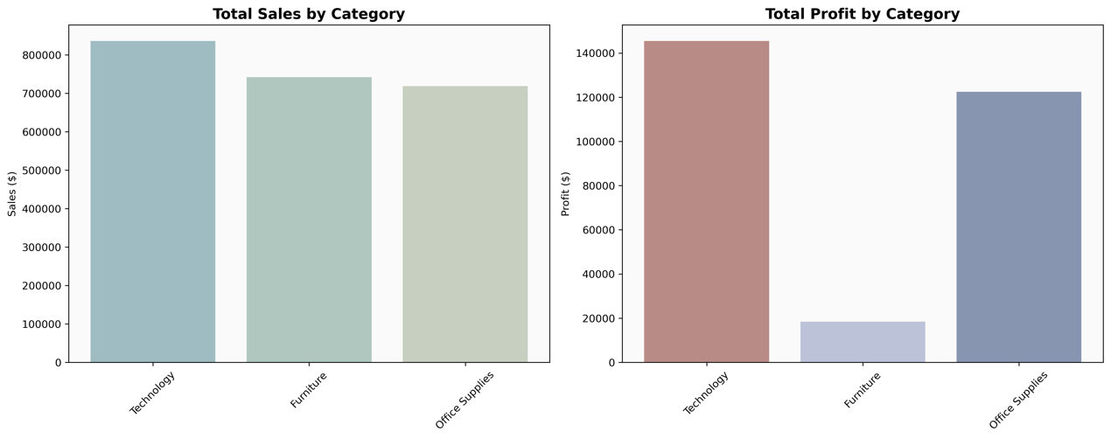

Why it's interesting/important:
• Strong sales performance: The Technology category generated the highest revenue at approximately $836K, highlighting its significant contribution to overall business growth.
• Profitability differences: Although Technology achieved the highest sales, Office Supplies demonstrated more consistent profit margins, indicating stronger profitability stability.
• Business strategy support: The analysis helps identify the right balance between high-revenue and high-margin product categories.
• Decision-making insights: Findings provide valuable guidance for inventory planning, resource allocation, and marketing investments.

2. Visualization: Regional sales distribution, profit comparison, Top 10 states by sales, and profit margin analysis
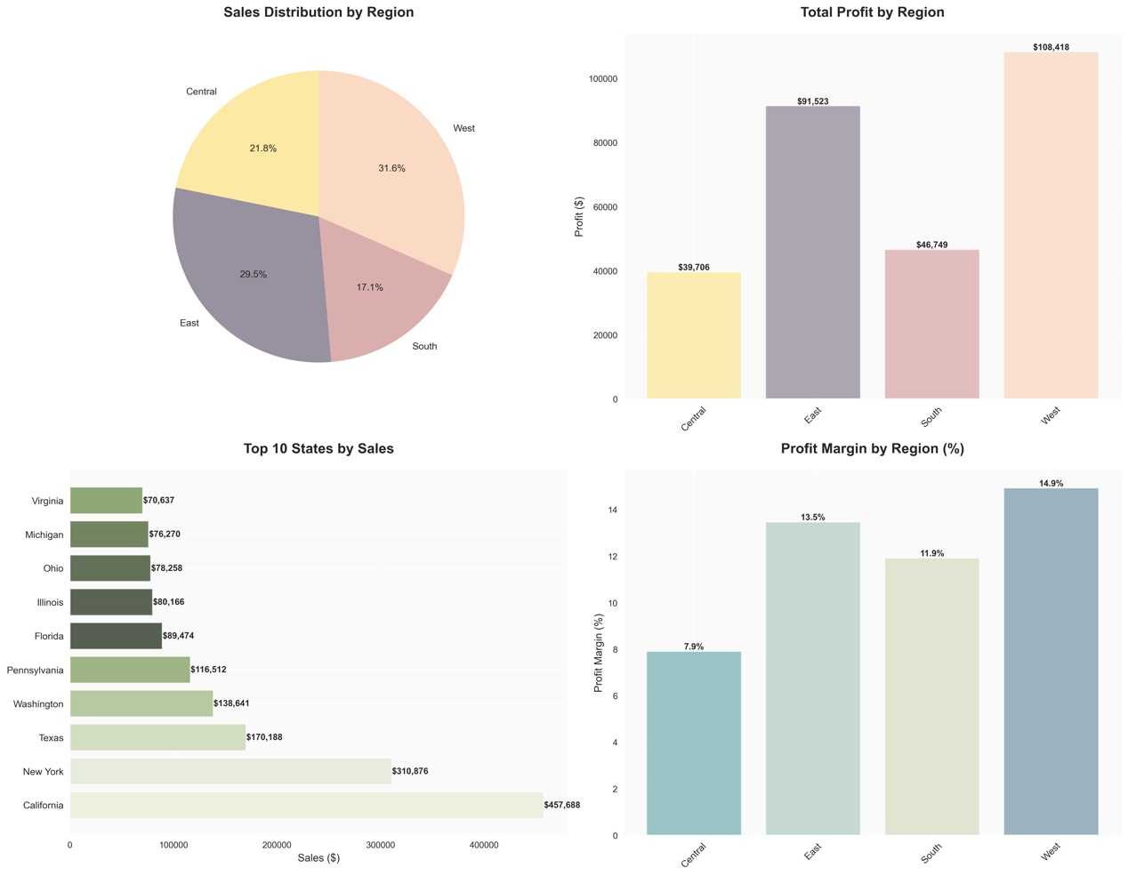
Why it's interesting/important:
• Strong regional performance: The West region contributed 31.6% of total sales while maintaining a profit margin of 14.9%, making it the highest-performing market in the analysis.
• High-potential geographic markets: California, New York, and Texas emerged as the leading states in terms of sales, indicating strong opportunities in densely populated regions.
• Profitability trends across regions: The East and West regions achieved higher profit margins, suggesting more effective operations, stronger market demand, or successful pricing strategies.
• Strategic expansion insights: The regional analysis provides valuable guidance for future investments, market expansion initiatives, and efficient allocation of sales resources.

3. Visualization: Customer segment distribution, sales contribution, average order value, and profit analysis
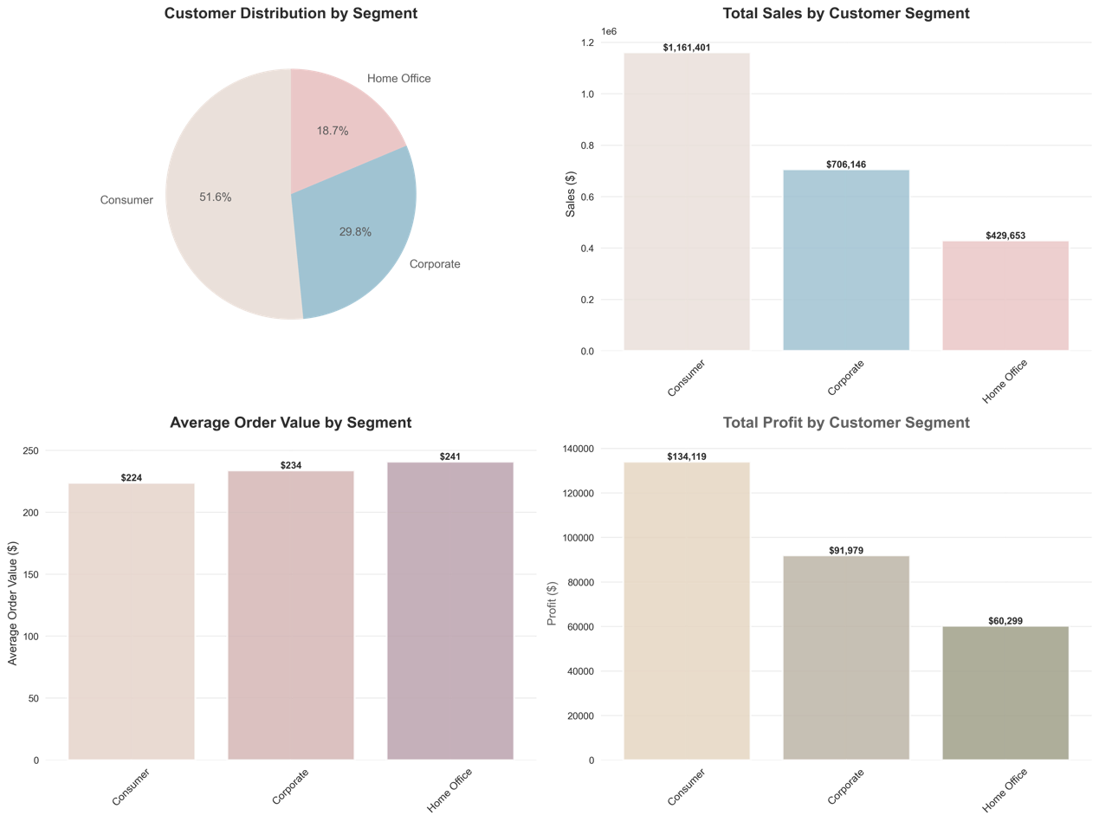
Why it's interesting/important:
• Consumer segment leadership: The Consumer segment accounted for 51.6% of the customer base and generated the highest sales revenue of approximately $1.16M, making it the primary driver of business performance.
• Home Office growth opportunity: Although the Home Office segment represented only 18.7% of customers, it achieved the highest average order value of $241, highlighting its potential as a high-value market.
• Customer segmentation insights: The analysis revealed distinct purchasing behaviors across customer segments, emphasizing the need for targeted marketing and engagement strategies.
• Strategic customer management: These findings can support better decisions related to customer acquisition, retention initiatives, and long-term customer value optimization.

4. Visualization: Monthly sales trends, profit trends, order count patterns, and sales-profit correlation analysis
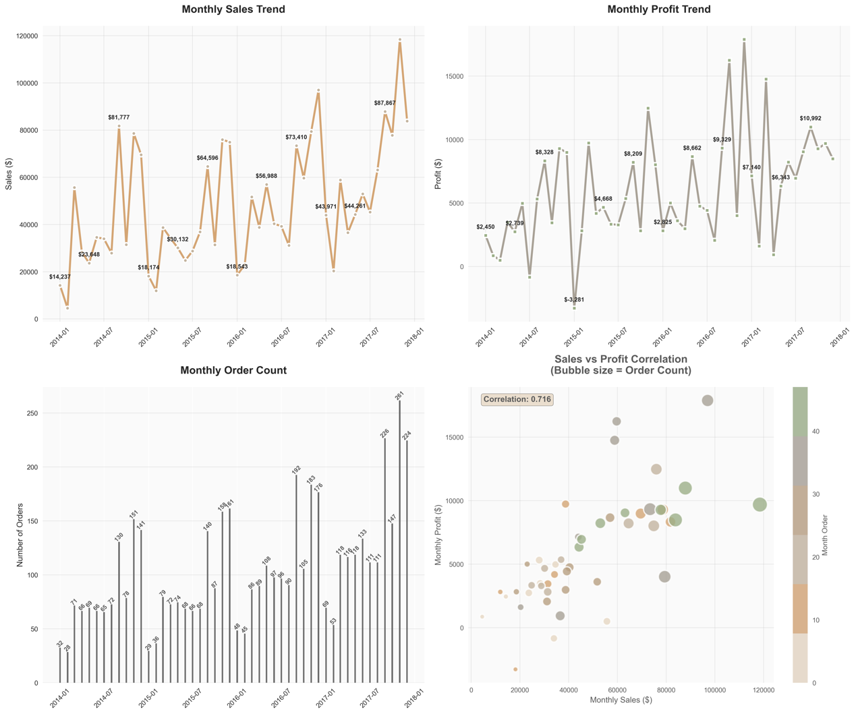
Why it's interesting/important:
• Seasonal sales trends: Sales consistently increased toward the end of the year, reflecting the influence of holiday seasons and year-end business activities.
• Positive sales-profit relationship: A correlation coefficient of 0.716 indicates a strong connection between revenue growth and profitability.
• Business growth evidence: The noticeable increase in sales and profit during late 2017 suggests successful expansion and improved business performance.
• Forecasting opportunities: Historical sales patterns can be used to support future demand forecasting and inventory management strategies.
• Financial planning support: Understanding revenue fluctuations enables more effective budgeting, cash flow management, and resource allocation.



